Data Analytics (DA)

“Data Transformation, Modeling & Visualization with Power BI”

TITLE: EXECUTIVE FINANCIAL ANALYSIS USING POWER BI

DATA CONNECTION, IMPORT, INTERFACE EXPLORATION

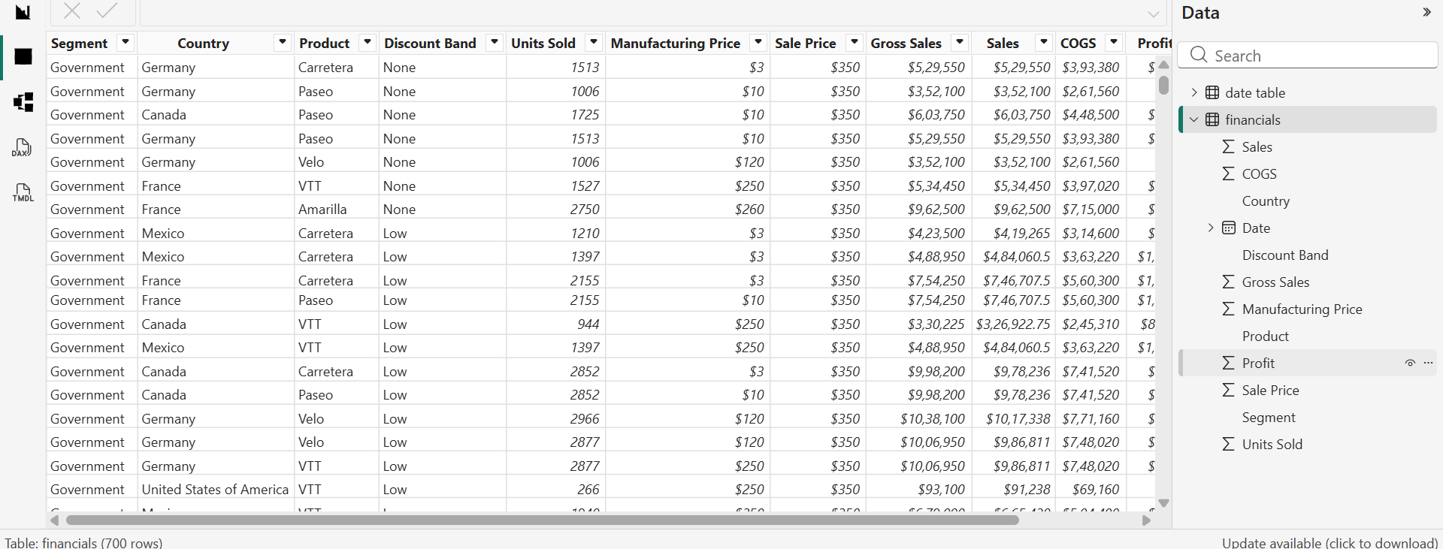

DATA CLEANING & TRANSFORMATION
- Formatted & Transformed Columns in Power Query

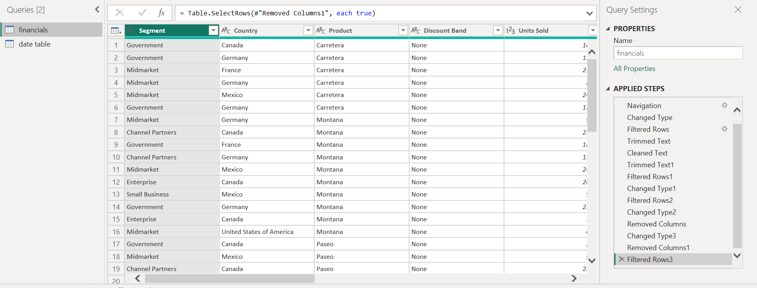

- Date table created
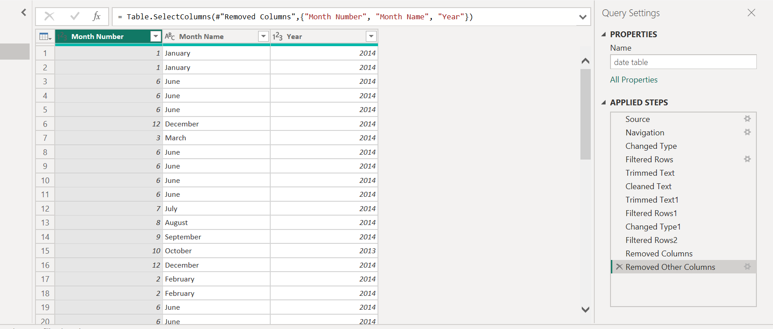

Data Modeling
  - Built Tables, Defined Relationships
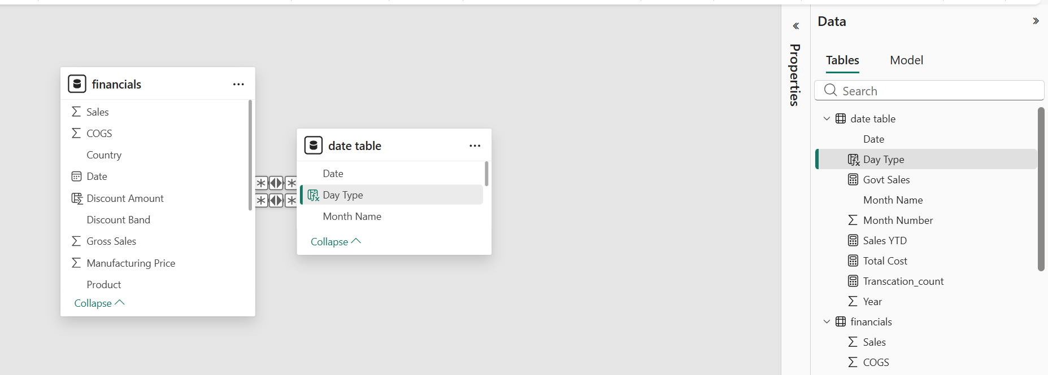
DAX & CALCULATIONS
- Created calculated measures:
- Total Units = SUM(financials[Units Sold])
- Govt Sales = CALCULATE(SUM(financials[ Sales]), financials[Segment] = "Government")
- Total Cost = SUM(financials[COGS])
- Sales YTD = TOTALYTD(SUM(financials[ Sales]), 'date table'[Date])
- Transcation_count = DISTINCTCOUNT(financials[Product])

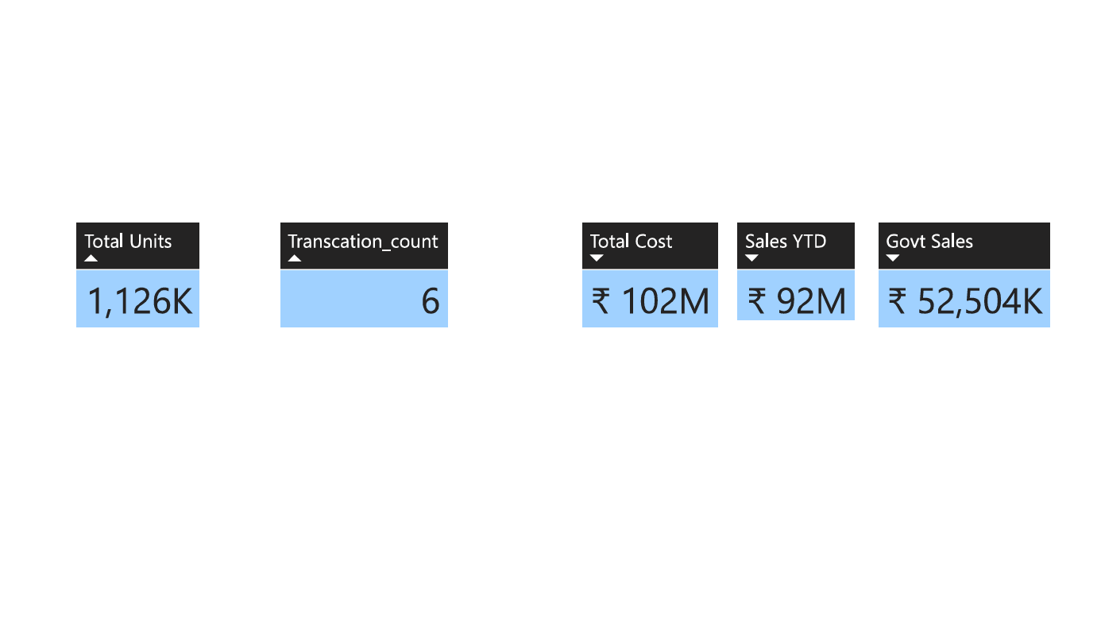

Descriptive Statistics

- Total Units (1,126K): This represents the Aggregate Sum () of the units sold. In descriptive terms, it defines the Total Volume of physical inventory moved during the specified period, establishing the scale of business operations.
- Transaction count (6): This is a Frequency Count of Unique Categories. Statistically, this represents the count of distinct time periods (such as months or years) present in the data, indicating the Temporal Breadth of the dataset being analyzed.
- Total Cost (₹102M): This represents the Cumulative Sum of all expenses (COGS). Descriptively, it quantifies the Total Resource Outflow required to generate the current business volume, serving as the primary baseline for expenditure analysis.
- Sales YTD (₹92M): This is a Time-Series Aggregate. It measures the Cumulative Frequency of Revenue from the start of the fiscal year to the current date, providing a benchmark for year-to-date performance against annual targets.
- Govt Sales (₹52,504K): This is a Filtered Sub-total. It describes the Segmented Contribution of the Government sector to the total revenue. Statistically, it shows that this single segment drives more than 50% of the Year-to-Date sales.

CREATED CALCULATED COLUMNS

“DAY TYPE” column created
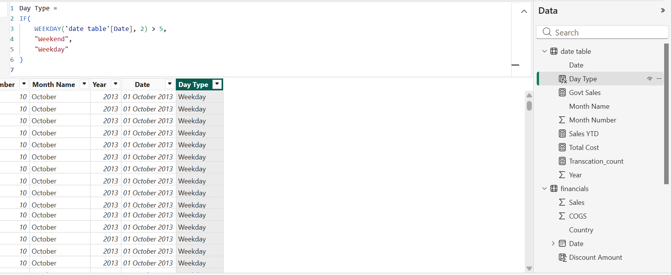

“DISCOUNT AMOUNT” column created
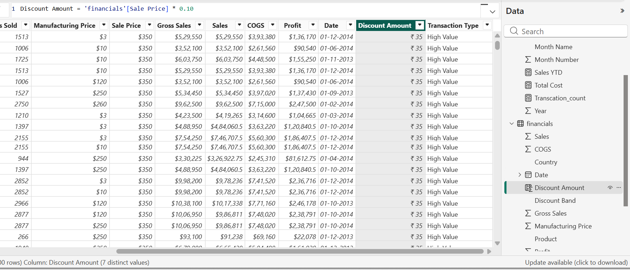
“TRANSACTION TYPE “column created
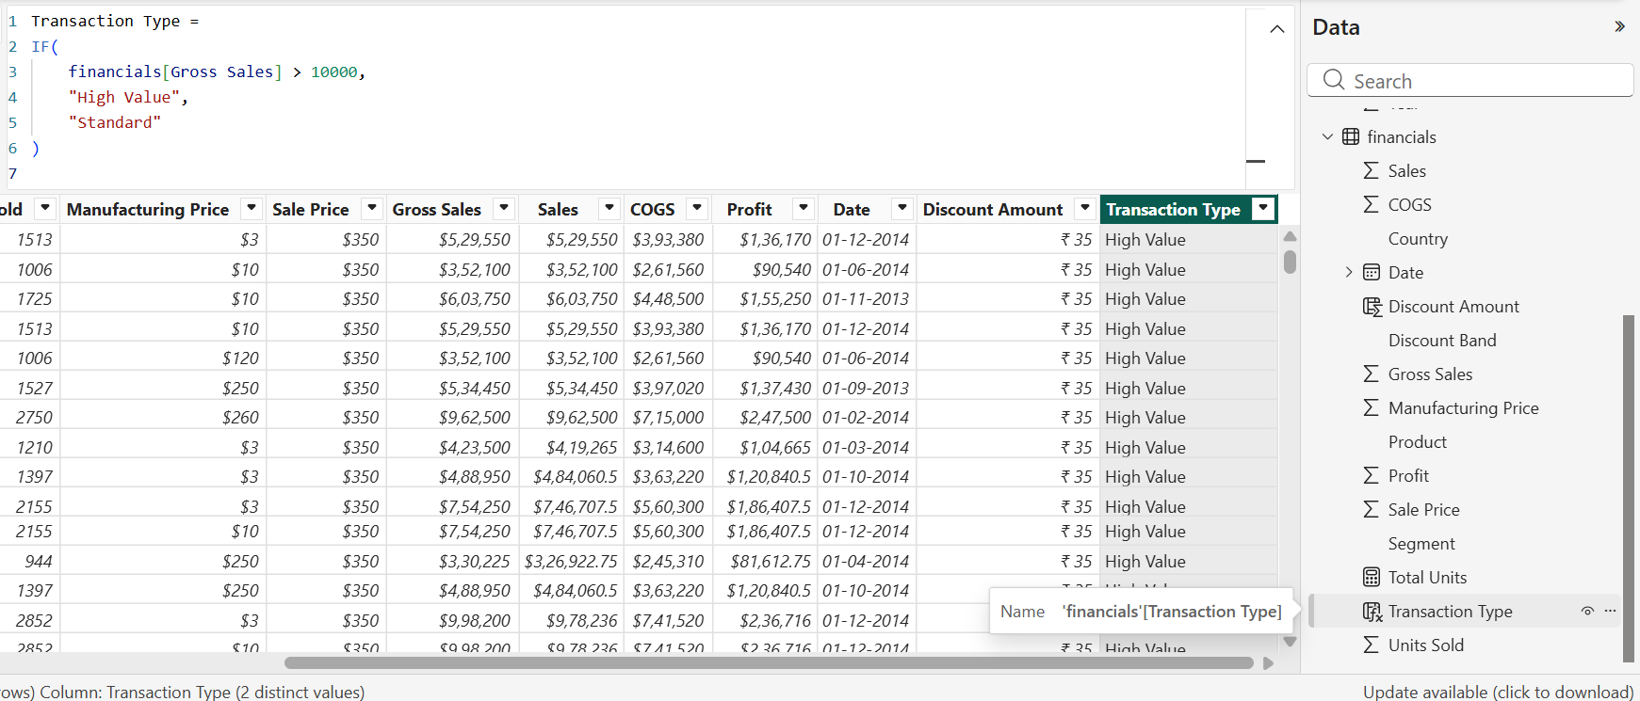

DATA VISUALIZATION
INSIGHTS:
1.Key Performance Indicators (KPIs)
- Total Volume: The business moved 1,126K units, indicating high market penetration and operational scale.
- Revenue vs. Expenditure: Total Sales YTD stands at ₹92M, while Total Cost is ₹102M. This reveals a ₹10M deficit, suggesting that current production or operational costs are outpacing revenue.
- Core Revenue Driver: Government Sales (₹52,504K) account for approximately 57% of total Year-to-Date sales, identifying the public sector as the primary revenue stream.

2. Profitability by Segment
- Top Performer: The Government segment is the most profitable, contributing $11.39M.
- Critical Underperformer: The Enterprise segment is currently operating at a loss of $0.61M. This is a priority area for cost restructuring or pricing adjustments.
- Supporting Segments: Small Business ($4.14M) and Channel Partners ($1.32M) remain healthy contributors to the bottom line.
3. Operational & Sales Trends
- Temporal Growth: The Sales by Year donut chart shows that 2014 saw a massive expansion compared to 2013, representing the majority of the current dataset's value.
- Daily Activity: Weekdays consistently outperform weekends in terms of units sold.
- Discount Strategy: High-volume sales are largely driven by "None" or "Low" discount bands. This suggests that the product maintains strong demand without requiring aggressive price slashing.
4. Geographic Cost Distribution
- The global map indicates that Total Cost is heavily concentrated in North America and Europe. While these are major markets, the high cost-to-revenue ratio in these regions may be contributing to the overall ₹10M deficit.

Conclusion
- Cost Optimization: Investigate the ₹10M gap between Cost and Sales, focusing on high-cost regions identified in the map.
- Enterprise Pivot: Analyse the Enterprise segment loss to determine if the issue lies in high manufacturing prices or insufficient sale prices.
- Capitalize on Momentum: Leverage the high-volume, low-discount success seen on Weekdays to further reduce reliance on price-cutting strategies.

